**PO2EBL_ELECTRIC BLENDER**

**HSI DOCUMENT**

**Version 1.8**

**Proposed**

# Document Status:

|  |  |  |  |
| --- | --- | --- | --- |
| **Date** | **Version** | **Document Status** | **Author** |
| 02/8/2020 | 1.8 | Proposed | Amira Zaher |

# Revision History

|  |  |  |  |
| --- | --- | --- | --- |
| **Date** | **Version** | **Description** | **Author** |
| 01/23/2020 | 1.1 | Initial Draft, mentioning all the hardware components needed for the system. | Amira Zaher |
| 01/26/2020 | 1.2 | Update Pin Mode Representation | Ali Samir |
| 01/31/2020 | 1.3 | Update the functional requirement | Amira Zaher |
| 02/1/2020 | 1.4 | Update the document header | Amira Zaher |
| 02/5/2020 | 1.5 | Adding Table of Content | Amira Zaher |
| 02/6/2020 | 1.6 | Update Functional Requirements with the number 5 requirement (Transistor) | Amira Zaher |
| 02/8/2020 | 1.7 | Update the Pin representation and the Functional Requirements | Amira Zaher |
| 02/8/2020 | 1.8 | Final Update of the review points | Amira Zaher |

Contents

Document Status: 2

Revision History 3

1. Introduction 5

1.1 Hardware Requirement 5

2. Hardware System: 5

2.1 The System Block Diagram 5

2.2 Pin Mode Representation 6

3. Functional Requirements: 6

4. Reference Table: 7

# Introduction

This section introduces the hardware specification for the project.

## 1.1 Hardware Requirement

This specification documents all the hardware requirements for the Electric Blender including:

* Microcontroller (AVR Atmega32)
* Push button
* LED
* DC motor
* Transistor

# Hardware System:

## 2.1 The System Block Diagram

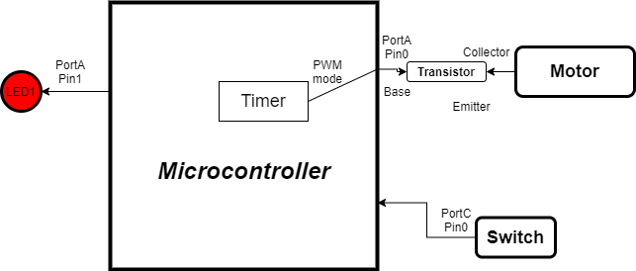

## 2.2 Pin Mode Representation

|  |  |  |  |  |
| --- | --- | --- | --- | --- |
| **Component Name** | **Req_ID** | **Pin** | **Mode** | **Function** |
| Motor | REQ_PO2EBL_HSI_01_V02 | VCC Transistor Collector | 5V Input | Operates when the Transistor base is HIGH |
| LED | REQ_PO2EBL_HSI_03_V02 | PA1 GND | Digital Output | Operate when it receives HIGH based on the state of the Motor |
| Push Button | REQ_PO2EBL_HSI_02_V02 | PC0 GND | Digital Input pull up | Gives the signal to the motor pin |
| Transistor | REQ_PO2EBL_HSI_04_V02 | PA0 (B) Motor (C) GND (E) | Digital Output | Maintain the level of isolation between the microcontroller and the motor |

# Functional Requi­­rements:

|  |  |
| --- | --- |
| **REQ_ID** | **Description** |
| REQ_PO2EBL_HSI_01_V02 | * In order to get the motor speed: DC motor   #imp HW |
| REQ_PO2EBL_HSI_02_V02 | * In order to control the speed of the blender: Push Button   #imp HW |
| REQ_PO2EBL_HSI_03_V02 | * In order to show the speed level of the blender: LED   #imp HW |
| REQ_PO2EBL_HSI_04_V02 | * In order to maintain the isolation level between the microcontroller and the motor acts as Safety Monitor: Transistor   #imp HW |

# Reference Table:

|  |  |  |  |
| --- | --- | --- | --- |
| **ID** | **Version** | **Status** | **Document** |
| 1 | 1.0 | Released | Electric Blender customer requirement |
| 2 | - | - | SIQ |